Communication preferences

Template

Step 1:

1. In the first column, from the list of behaviors below, please choose the top 7 that most resonate with you, by marking a tick ✓ next to it.
2. On the second column, from the 7 behaviors that you have ticked, now select your top 5 and rank them from most like you (1) to least like you (5).

|  |  |  |
| --- | --- | --- |
| Behavior | My top 7 ✓ | Rank your top 5  *(1 = most like you; 5 = least like you)* |
| Likes challenges |  |  |
| Results focused | Y | 3 |
| Competitive | Y | 4 |
| Determined |  |  |
| Assertive |  |  |
| Decisive |  |  |
| Risk Taker |  |  |
| Sensitive to others | Y | 6 |
| Sociable | Y | 7 |
| Emotional | Y | 2 |
| Stimulating |  |  |
| Outgoing |  |  |
| Optimistic | Y | 1 |
| Enthusiastic |  |  |
| Tactful |  |  |
| Calm |  |  |
| Patient |  |  |
| Dependable |  |  |
| Supportive |  |  |
| Accommodating |  |  |
| Procedure orientated | Y | 5 |
| Precise |  |  |
| Private |  |  |
| Systematic |  |  |
| Restrained |  |  |
| Likes numbers |  |  |
| Perfectionist |  |  |
| Critical of mistakes |  |  |

Step 2:

Now please complete your research. Here is a reminder of DiSC. The example behaviors are drawn from the previous table.

Introducing the DiSC model

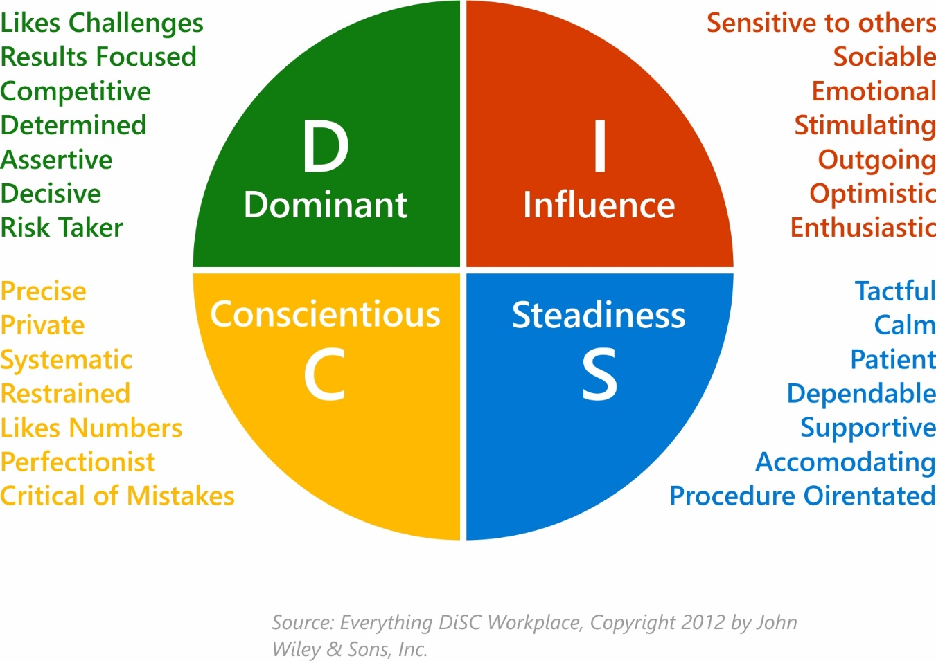

Step 3:

Following your research, answer the final 2 questions below.

1. What have you learned about yourself from the DiSC model?

That I show a dominant personality as well as influencial traits more.

1. What have you learned about DiSC and its value when communicating with others?

Communication becomes positive, Misconceptions can be avoided between colleagues. We can get well with our colleagues.